ASSIGNMENT-9.4
H NO:2303A51685
Batch-13
Lab 9 – Documentation Generation: Automatic Documentation and Code
Comments

Task 1: Auto-Generating Function Documentation in a Shared Codebase Scenario
You have joined a development team where several utility functions are already implemented, but the code lacks proper documentation. New team members are struggling to understand how these functions should be used.

Task Description
You are given a Python script containing multiple functions without any docstrings.
Using an AI-assisted coding tool:
- Ask the AI to automatically generate Google-style function docstrings for each function
- Each docstring should include:
  - A brief description of the function
  - Parameters with data types
  - Return values
  - At least one example usage (if applicable)
Experiment with different prompting styles (zero-shot or context-based) to observe quality differences.

Expected Outcome
- A Python script with well-structured Google-style docstrings
- Docstrings that clearly explain function behavior and usage
- Improved readability and usability of the codebase

Prompt:
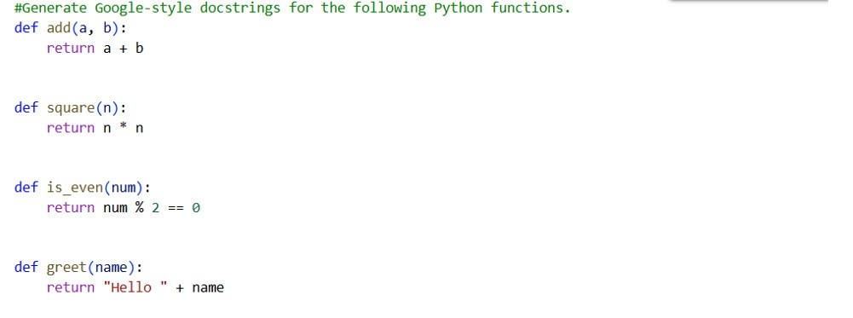

Output Docstring
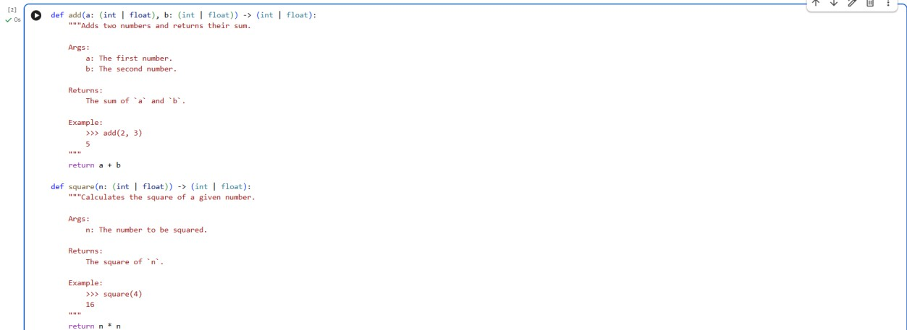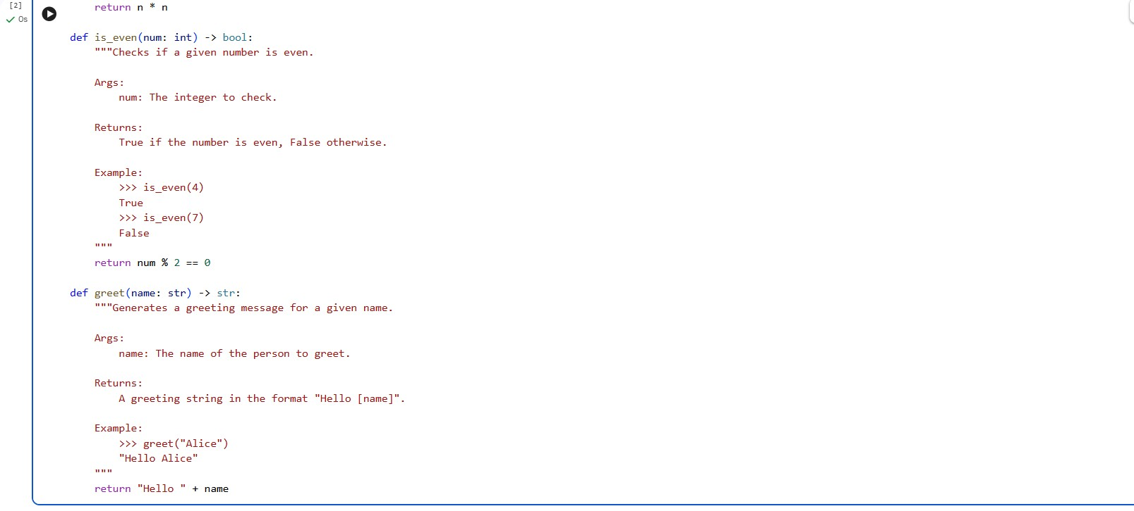
Justification:
The AI-generated Google-style docstrings clearly describe each function’s purpose, parameters, return values, and example usage. This improves code readability and helps new developers quickly understand how to use the functions correctly. Including type hints and examples reduces ambiguity and potential misuse. Overall, the documentation enhances maintainability and makes the codebase more professional and user-friendly. Task 2: Enhancing Readability Through AI-Generated Inline Comments

Scenario
A Python program contains complex logic that works correctly but is difficult to understand at first glance. Future maintainers may find it hard to debug or extend this code.

Task Description
You are provided with a Python script containing:
- Loops
- Conditional logic
- Algorithms (such as Fibonacci sequence, sorting, or searching) Use AI assistance to:
- Automatically insert inline comments only for complex or non- obvious logic
- Avoid commenting on trivial or self-explanatory syntax
The goal is to improve clarity without cluttering the code.

Expected Outcome
- A Python script with concise, meaningful inline comments • Comments that explain why the logic exists, not what Python syntax does
- Noticeable improvement in code readability Prompt:
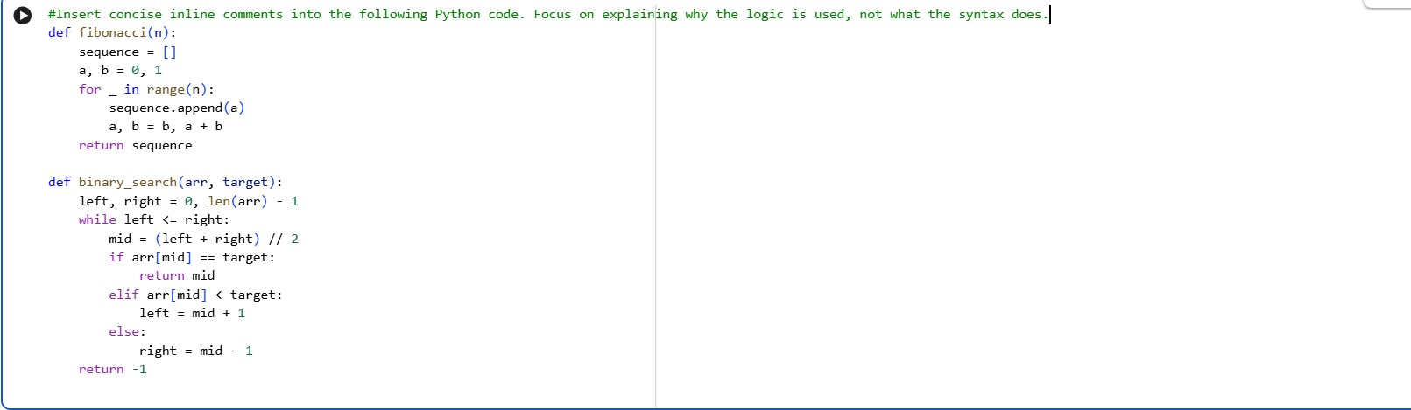

Output Docstring
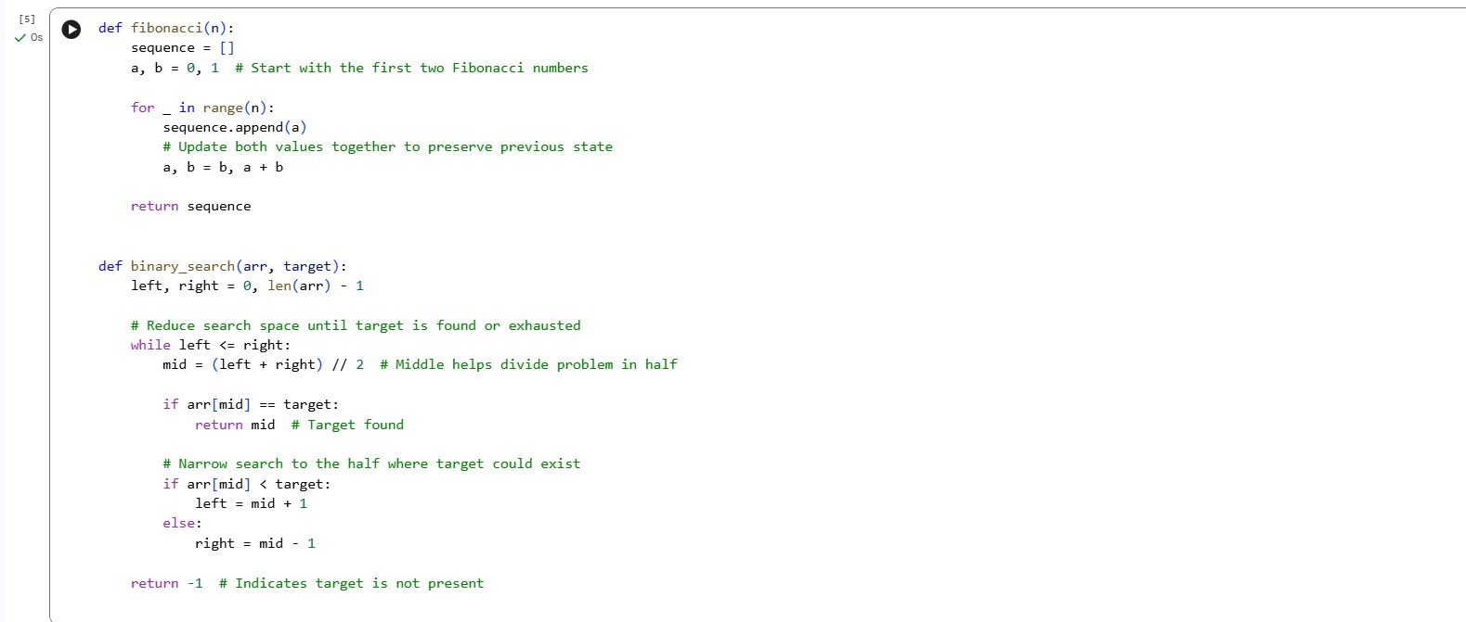
Justification:
The inline comments improve readability by explaining the reasoning behind important algorithmic steps, such as updating Fibonacci values together and narrowing the search space in binary search. They focus on why the logic is used rather than describing basic Python syntax. This makes the code easier to understand, debug, and maintain. Overall, the script becomes clearer without adding unnecessary clutter.

Task 3: Generating Module-Level Documentation for a Python Package Scenario
Your team is preparing a Python module to be shared internally (or uploaded to a repository). Anyone opening the file should immediately understand its purpose and structure.

Task Description
Provide a complete Python module to an AI tool and instruct it to automatically generate a module-level docstring at the top of the file that includes:
- The purpose of the module
- Required libraries or dependencies
- A brief description of key functions and classes
- A short example of how the module can be used Focus on clarity and professional tone.

Expected Outcome
- A well-written multi-line module-level docstring
- Clear overview of what the module does and how to use it
- Documentation suitable for real-world projects or repositories Prompt:
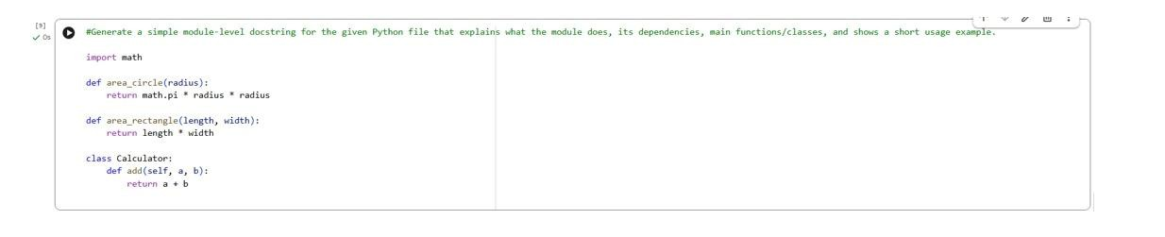
OUTPUT:
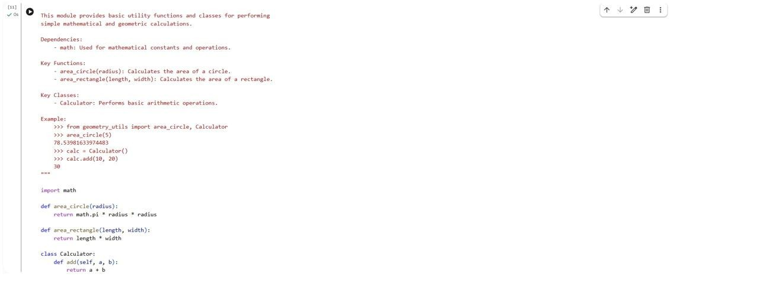
Justification:
Adding a module-level docstring provides a clear overview of the module’s purpose, dependencies, and structure, making it easier for developers to understand the code quickly. It improves readability and ensures consistency across the project. Including a usage example enhances usability by showing how the module should be implemented. Overall, it makes the code more professional and suitable for real-world repositories.

Task 4: Converting Developer Comments into Structured Docstrings Scenario
In a legacy project, developers have written long explanatory comments inside functions instead of proper docstrings. The team now wants to standardize documentation.

Task Description
You are given a Python script where functions contain detailed inline comments explaining their logic.
Use AI to:
- Automatically convert these comments into structured Google-style or NumPy-style docstrings
- Preserve the original meaning and intent of the comments
- Remove redundant inline comments after conversion

Expected Outcome
- Functions with clean, standardized docstrings
- Reduced clutter inside function bodies • Improved consistency across the codebase PROMPT:
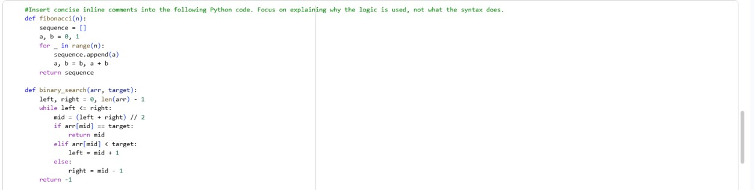
GOOGLE-STYLED DOCSTRING OUTPUT:
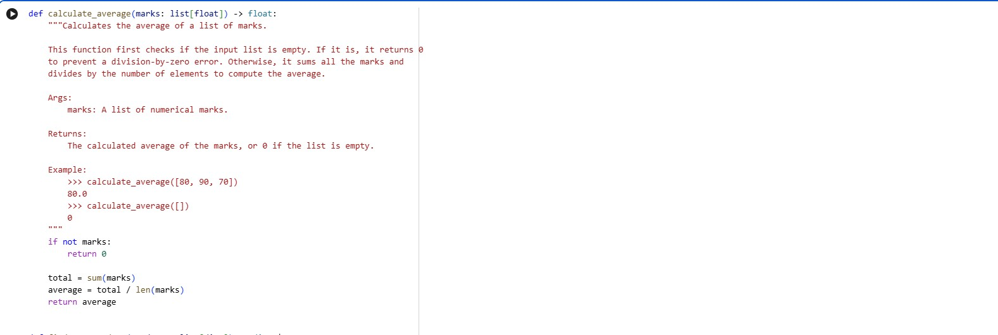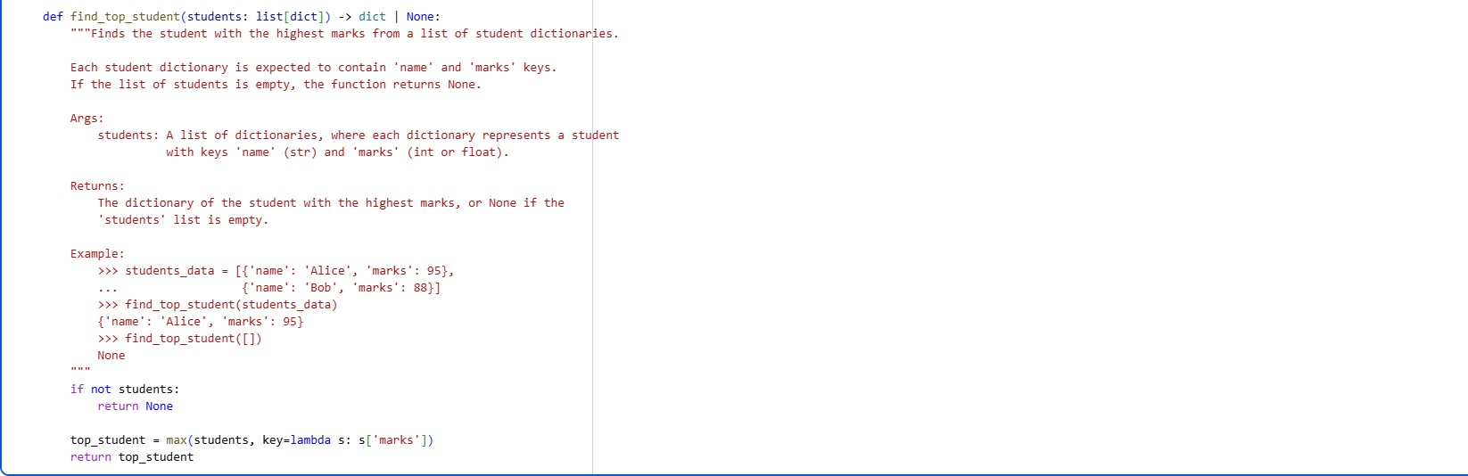
Justification:The conversion to Google-style docstrings significantly enhances code readability and maintainability. These docstrings provide a clear, structured explanation of each function's purpose, arguments (with types), return values, and include practical examples. This makes the code much easier for others to understand and use.

Task 5: Building a Mini Automatic Documentation Generator Scenario
Your team wants a simple internal tool that helps developers start documenting new Python files quickly, without writing documentation from scratch.

Task Description
Design a small Python utility that:
• Reads a given .py file • Automatically detects:
o Functions o Classes
• Inserts placeholder Google-style docstrings for each detected function or class
AI tools may be used to assist in generating or refining this utility.
Note: The goal is documentation scaffolding, not perfect documentation.

Expected Outcome
- A working Python script that processes another .py file
- Automatically inserted placeholder docstrings
- Clear demonstration of how AI can assist in documentation automation Prompt:
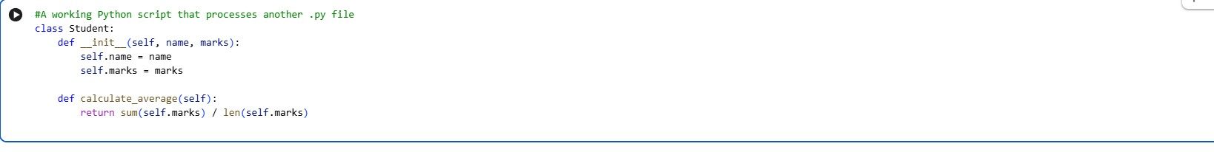

OUTPUT
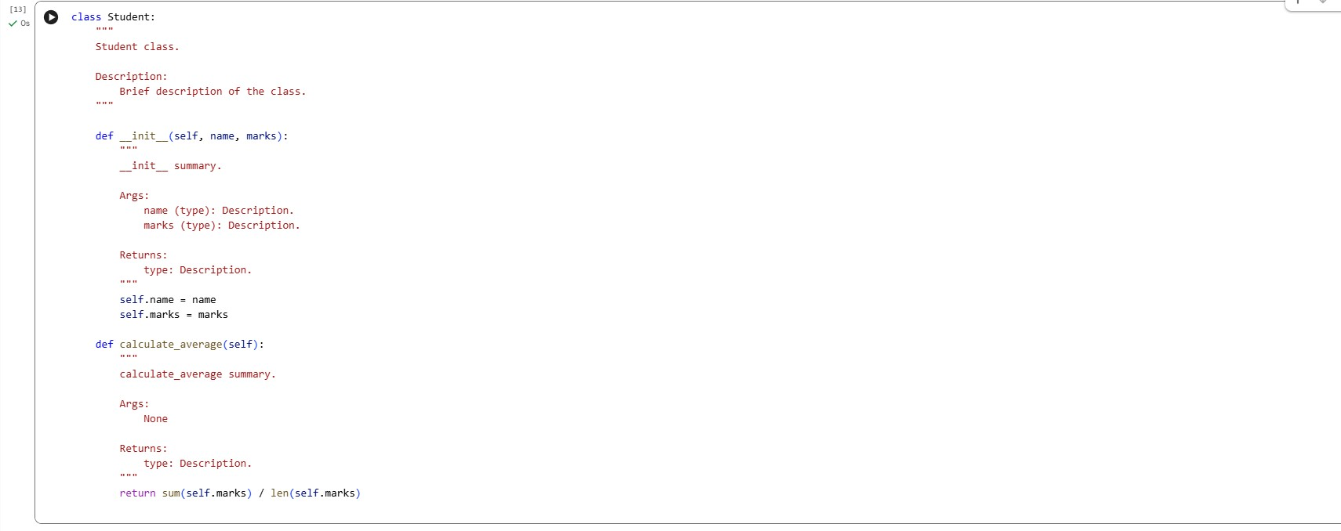
JUSTIFICATION:
The Mini Automatic Documentation Generator helps developers quickly scaffold documentation for new Python files, reducing manual effort and saving time. By automatically inserting structured Google-style docstrings, it ensures consistency and improves code readability. The tool preserves existing logic and documentation, making it safe to use in real projects. This demonstrates how AI-assisted automation can enhance documentation quality and maintainability.

